**QUANTITATIVE METHODS**

Table of Contents

Reading 6: The Time Value of Money 7

a. Interpret interest rates as required rates of return, discount rates, or opportunity costs 7

b. Explain an interest rate as the sum of a real risk-free rate and premiums that compensate investors for bearing distinct types of risk 7

c. Calculate and interpret the effective annual rate, given the stated annual interest rate and the frequency of compounding 7

d. Solve time value of money problems for different frequencies of compounding 7

e. Calculate and interpret the future value (FV) and present value (PV) of a single sum of money, an ordinary annuity, an annuity due, a perpetuity (PV only), and a series of unequal cash flows 8

f. Demonstrate the use of a time line in modeling and solving time value of money problems 9

Reading 7: Discounted Cash Flow Applications 10

f. Calculate and interpret the net present value (NPV) and the internal rate of return (IRR) of an investment 10

f. Contrast the NPV rule to the IRR rule, and identify problems associated with the IRR rule 10

f. Calculate and interpret a holding period return (total return) 10

f. Calculate and compare the money-weighted rates of return of a portfolio and evaluate the performance of portfolios based on these measures 10

f. Calculate and interpret the bank discount yield, holding period yield, effective annual yield, and money market yield for the US Treasury bills and other money market instruments. 11

f. Convert among holding period yields, money market yields, effective annual yields and bond equivalent yields 12

Reading 8: Statistical Concepts and Market Returns 13

a. Distinguish between descriptive statistics and inferential statistics, between a population and a sample, and among the types of measurement scales. 13

b. Define a parameter, a sample statistic, and a frequency distribution 13

c. Calculate and interpret relative frequencies and cumulative relative frequencies, given a frequency distribution. 13

d. Describe the properties of a data set presented as a histogram or frequency polygon. 14

e. Calculate and interpret measures of central tendency, including the population mean, sample mean, arithmetic mean, weighted average or mean, geometric mean, harmonic mean, median and mode. 14

f. Calculate and interpret quartiles, quintiles, deciles and percentiles. 16

g. Calculate and interpret 1) a range and a mean absolute deviation and 2) variance and standard deviation of a population and of a sample. 16

h. Calculate and interpret the proportion of observation falling within a specified number of standard deviations of the mean using Chebyshev’s inequality. 17

i. Calculate and interpret the coefficient of variation and the Sharpe ratio. 17

j. Explain skewness and the meaning of a positively or negatively skewed return distribution. 18

k. Describe the relative locations of the mean, median and mode for a unimodal, nonsymmetrical distribution. 18

l. Explain measures of sample skewness and kurtosis. 19

m. Compare the use of arithmetic and geometric means when analyzing investment returns. 20

Reading 9: Probability Concepts 21

a. Define a random, an outcome, an event, mutually exclusive events and exhaustive events 21

b. State the two defining properties of probability and distinguish among empirical, subjective and a priori probabilities 21

c. State the probability of an event in terms of odds for and against the event 21

d. Distinguish between unconditional and conditional probabilities 21

e. Explain multiplication, addition and total probability rules 22

f. Calculate and interpret the joint probability of two events, the probability of at least one of two events will occur, given the probability of each and the joint probability of the two events and a joint probability of any number of independent events 22

g. Distinguish between dependent and independent events 23

h. Calculate and interpret an unconditional probability using the total probability rule 23

i. Explain the use of conditional expectation in investment applications 24

j. Explain the use of a tree diagram to represent an investment problem 25

k. Calculate and interpret covariance and correlation 25

l. Calculate and interpret the expected value, variance and standard deviation of a random variable and of returns on a portfolio 26

m. Calculate and interpret covariance given a joint probability function 27

n. Calculate and interpret an updated probability using Bayes’ formula 27

o. Identify the most appropriate method to solve a particular counting problem and solve counting problems using factorial, combination and permutation concepts. 28

Reading 10: Common Probability Distributions 30

a. Define a probability distribution and distinguish between discrete and continuous random variables and their probability functions 30

b. Describe the set of possible outcomes of a specified discrete random variable 30

c. Interpret a cumulative distribution function 30

d. Calculate and interpret probabilities for a random variable given its cumulative distribution function 30

e. Define a discrete uniform random variable, a Bernoulli random variable and a binomial random variable 31

f. Calculate and interpret probabilities given the discrete uniform and the binomial distribution functions 31

g. Construct a binomial tree to describe stock price movement 32

h. Define the continuous uniform distribution and calculate and interpret probabilities, given a continuous uniform distribution 33

i. Explain the key properties of the normal distribution 33

j. Distinguish between a univariate and a multivariate distribution and explain the role of correlation 34

k. Determine the probability that a normally distributed random variable lies inside a given interval 34

l. Define the standard normal distribution, explain how to standardize a random variable and calculate and interpret probabilities using the standard normal distribution 34

m. Define shortfall risk, calculate the safety-first ratio and select an optimal portfolio using Roy’s safety-first criterion 35

n. Explain the relationship between normal and lognormal distributions and why the lognormal distribution is used to model asset prices 35

o. Distinguish between discretely and continuously compounded rates of return and calculate and interpret a continuously compounded rate of return, given a specific holding period of return 36

p. Explain Monte Carlo simulation and describe its applications and limitations 36

q. Compare Monte Carlo simulation and historical simulation 37

Reading 11: Sampling and Estimation 38

a. Define simple random sampling and a sampling distribution 38

b. Explain sampling error 38

c. Distinguish between simple random and stratified sampling 38

d. Distinguish between time-series and cross-sectional data 38

e. Explain the central limit theorem and its importance 38

f. Calculate and interpret the standard error of the sample mean 39

g. Identify and describe desirable properties of an estimator 39

h. Distinguish between a point estimate and a confidence interval estimate of a population parameter 39

i. Describe properties of Student’s t-distribution and calculate and interpret degrees of freedom 39

j. Calculate and interpret a confidence interval for a population mean, given a normal distribution with a known population variance, an unknown population variance or an unknown variance and a large sample size 40

k. Describe the issues regarding selection of the appropriate sample size, data-mining bias, sample selection bias, survivorship bias, look-ahead bias and time-period bias 42

Reading 12: Hypothesis Testing 43

a. Define a hypothesis, describe the steps of hypothesis testing, and describe and interpret the choice of the null and alternative hypotheses 43

b. Distinguish between one-tailed and two-tailed tests of hypotheses 43

c. Explain a test statistic, type I and type II error, a significance level, and how significance levels are used in hypothesis testing 44

d. Explain a decision rule, the power of a test and the relation between confidence intervals and hypothesis tests 44

e. Distinguish between a statistical result and an economically meaningful result. 45

f. Explain and interpret the p-value as it relates to hypothesis testing 45

g. Identify the appropriate test statistic and interpret the results for a hypothesis test concerning the population mean of both large and small samples when the population is normally or approximately normally distributed and the variance is 1) known or 2) unknown 46

h. Identify the appropriate test statistic and interpret the results for a hypothesis test concerning the equality of the population means of two at least approximately normally distributed populations, based on independent random samples with 1) equal or 2) unequal assumed variances 47

i. Identify the appropriate test statistic and interpret the results for a hypothesis test concerning the mean difference of two normally distributed populations 48

j. Identify the appropriate test statistic and interpret the results for a hypothesis test concerning 1) the variance of a normally distributed population, and 2) the equality of the variances of two normally distributed populations based on two independent random samples 49

k. Distinguish between parametric and nonparametric tests and describe situations in which the use of nonparametric tests may be appropriate 51

Reading 11: Technical Analysis 52

a. Explain principles of technical analysis, its applications and its underlying assumptions 52

b. Describe the construction of different types of technical analysis charts and interpret them 52

c. Explain uses of trend, support, resistances lines and change in polarity 53

d. Describe common chart patterns 53

e. Describe common technical analysis indicators (price-based, momentum, oscillators, sentiment and flow of funds) 54

f. Explain how technical analysts use cycles 56

g. Describe the key tenets of Elliott Wave Theory and the importance of Fibonacci numbers 56

f. Describe intermarket analysis as it relates to technical analysis and asset allocation 56

# Reading 6: The Time Value of Money

## Interpret interest rates as required rates of return, discount rates, or opportunity costs

Equilibrium interest rates are the required rate of return of an investment. This rate of return is in function of risk. Discount rates are usually the name given to interest rates when they are going to be used for discounting future cash flows (not the same as the discount rate that I have seen before). Also, interest rates can be seen as an opportunity cost of performing another activity.

## Explain an interest rate as the sum of a real risk-free rate and premiums that compensate investors for bearing distinct types of risk

The real risk-free rate refers to a rate with no inflation. Nominal risk-free rates are the ones that are commonly seen. Premiums come from inflation and some risks like the following ones:

Types of risk:

* Default risk: credit risk.
* Liquidity risk: The risk of receiving a value lower than the fair value of the investment if it must be sold for cash quickly.
* Maturity risk: Due to longer periods, interest rates are more volatile.

## Calculate and interpret the effective annual rate, given the stated annual interest rate and the frequency of compounding

The effective (actual) annual rate comes as an annual rate of return after being adjusted for different compounding periods.

EAR may be determined as follows:

EAR = (1 + periodic rate)^m – 1

where:

periodic rate = stated annual rate/m

m = the number of compounding periods per year

The shorter limit of compounding periods is called continuous compounded and follow the following formula:

er – 1 = EAR

## Solve time value of money problems for different frequencies of compounding

Can be calculated either by hand or using the TVM function from the calculator.

## Calculate and interpret the future value (FV) and present value (PV) of a single sum of money, an ordinary annuity, an annuity due, a perpetuity (PV only), and a series of unequal cash flows

**Future value of a single sum:**

FV = PV(1+I/Y)^N

(1+I/Y)^N -> FV factor or FV interest factor

**Present value of a single sum:**

The process of bringing flows to PV is commonly known as discounting and the discount rate is also known as the opportunity cost, required rate of return and cost of capital.

PV = FV/(1+I/Y)^N

1/(1+I/Y)^N -> PV dactor, PV interest factor or discount factor.

**Annuities:**

Steam of equal cash flows that occur at equal intervals of time.

Ordinary annuity: cash flows occur at the end of the period.

Annuity due: cash flows occur at the beginning of the period.

Whenever I am planning to calculate the present value of a bond or any sort of investment which will end with a certain future value, it is important to consider changing the FV from zero to the desired number.

**Future Value of an Annuity Due:**

It can be calculated either by using the BEG mode of the calculator or by calculating an ordinary annuity and the multiplying the FV by (1+I/Y). It is important to take into account that when using the BGN mode, the FV is calculated one period after the last cash flow is generated.

**Present Value of an Annuity Due:**

The PV of an annuity due will always be greater than the one of an ordinary annuity, as there is one less discounting period (first CF occurs at t=0, which means that it is already a PV). As with the FV of annuity dues, the PV can also be computed by calculating the ordinary PV and multiplying the answer by (1+I/Y).

**Present Value of a Perpetuity**

Preferred stocks are great examples of perpetuities. From this assumption is how the perpetuities are calculated and used in valuation.

PV = CF/(I/Y)

Where CFs are constant through time. If, for instance, a firm is expected to start paying dividends in four years, the formula can be used, and the value should be brought to t=0 as a normal PV.

**PV and FV of Uneven Cash Flow Series:**

When this happens, it is not called an annuity.

## Demonstrate the use of a time line in modeling and solving time value of money problems

**Loan Payments and Amortization**

Loan amortization -> paying off a loan with periodic payments.

Usually, payments of loans are done with equal and periodic payments (including both principal and interest payments).

Once you have solved for the payment, $2,637.97, the remaining principal on any payment date can be calculated by entering N = number of remaining payments and solving for the PV.

**Other Applications of TVM Functions**

Calculation of annual compounded growth rates and periods of an specific growth.

**Funding a Future Obligation**

Annuities can be used to determine how much money is needed to be invested in order to receive certain payments in the future. An example of these cases are retirement plans.

**The Connection Between PV, FV and Series of CFs**

Cash flow additivity principle -> summing two PV is the same as summing two FV in time t and bringing the result to t=0.

# Reading 7: Discounted Cash Flow Applications

## Calculate and interpret the net present value (NPV) and the internal rate of return (IRR) of an investment

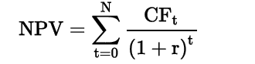

## Contrast the NPV rule to the IRR rule, and identify problems associated with the IRR rule

NPV rule -> When a project has a positive NPV, the amount goes to the shareholders. Then, accept projects with positive NPV. The higher, the better.

IRR rule -> Accept projects which IRR is higher than the required rate of return.

**Problems Associated with the IRR Method**

The IRR assumes that the reinvestment rate is the IRR while the NPV assumes that it is the cost of capital. Then, when the NPV and IRR give conflicting situations, always accept the project with the highest NPV.

## Calculate and interpret a holding period return (total return)

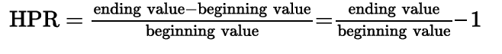

## Calculate and compare the money-weighted rates of return of a portfolio and evaluate the performance of portfolios based on these measures

Money-weighted return is the IRR of a portfolio. It is important to take into consideration that the outflows and inflows have an assigned sign (+/-) from the perspective of the account.

Time-weighted rate of return measures a compounded growth. It is computed by creating sub periods of the total time horizon considering the moments where withdrawals and deposits happened. Then, compute the HPR for each sub period. Finally, multiply all of the factors (1+HPR). To present it in annual terms, a geometric mean can be used.

(1+time-weighted rate of return)^N = (1+HPR1)*(1+HPR2)…*(1+HPRn)

The time-weighted return is the preferred to show the performance of portfolio, as it does not consider the changes in balance of the portfolio.

If funds are contributed to an investment portfolio just before a period of relatively poor portfolio performance, the money-weighted rate of return will tend to be lower than the time-weighted rate of return. On the other hand, if funds are contributed to a portfolio at a favorable time (just prior to a period of relatively high returns), the money-weighted rate of return will be higher than the time-weighted rate of return. The money-weighted approach is appropriate when the manager has complete control of the flows.

## Calculate and interpret the bank discount yield, holding period yield, effective annual yield, and money market yield for the US Treasury bills and other money market instruments.

T-bills are quoted on a bank discount basis, which yield is calculated using the following formula: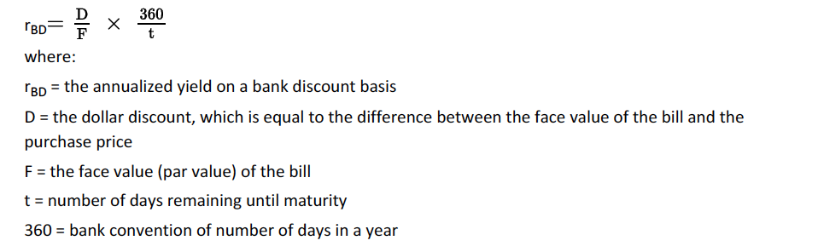

It is important to note that for this instrument, a 360 base is used rather than a 365 and no compounding is assumed.

The effective annual rate follows this formula (where HPY is HPR)



The money market yield is an annualized HPY assuming a 360 base.

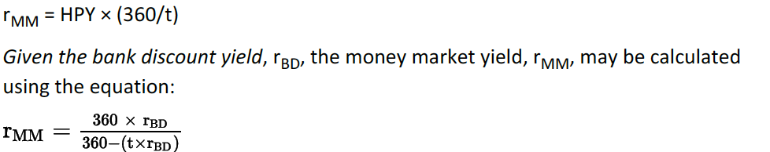

## Convert among holding period yields, money market yields, effective annual yields and bond equivalent yields

A bond equivalent yield refers to 2 x the semiannual discount rate.

Conversion between rates is easy, just bear in mind that:

HPY/HPR - Tasa efectiva

Money market yields- Tasa estipulada o anualizada

Effective anual yields or return- TAE

Bond equivalent yields or bank discount yield- Tasa de descuento anualizada

# Reading 8: Statistical Concepts and Market Returns

## Distinguish between descriptive statistics and inferential statistics, between a population and a sample, and among the types of measurement scales.

Descriptive statistics are used to summarize characteristics of data sets.

Inferential statistics refers to the procedures used to make forecasts or judgements from a sample.

A population is the set of data which includes all of the members of a group.

A sample, instead, is a subset of the population

**Measurement Scales:**

* Nominal scales: contains the least information where observations are classified or counted with no particular order.
* Ordinal scales: Implies an order of the data where there is a certain sense of why one group of the data is under one value and another group of data.
* Interval scale:
* Ratio scales:

NOIR (acrónimo)

## Define a parameter, a sample statistic, and a frequency distribution

Parameter-> measure used to describe characteristics of a population. Mean return and standard deviation of returns are examples.

Sample statistic-> instead of being for a population, it is used for samples.

Frequency distribution-> is a table that groups data sets. Sometimes the data is organized in groups or intervals (classes). Steps to build it:

1. Define intervals. They are all-inclusive and non-overlapping.
2. Tally the observations. Assign observations to intervals.
3. Count the observations. The absolute or simple frequency is the actual number of observations.

## Calculate and interpret relative frequencies and cumulative relative frequencies, given a frequency distribution.

The relative frequency is the portion of the absolute frequency that is in each interval.

Cummulative frequency are constructed by simply summing the frequency of the interval from the lowest to the highest for each class.

## Describe the properties of a data set presented as a histogram or frequency polygon.

A frequency polygon is constructed by calculating the midpoint of each interval (if the interval is 0 to 10, then the midpoint will be 5) and plotting each point considering the frequency of the interval. Then, a line should join the points.

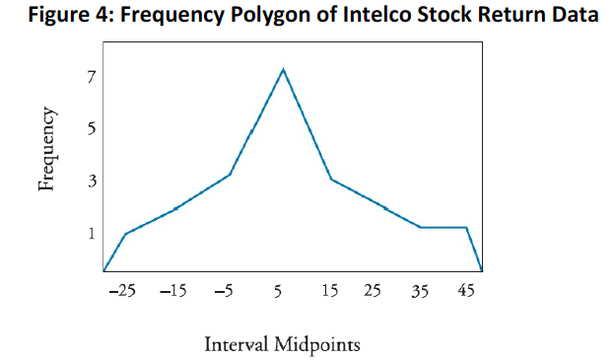

## Calculate and interpret measures of central tendency, including the population mean, sample mean, arithmetic mean, weighted average or mean, geometric mean, harmonic mean, median and mode.

Central tendency measures help to represent the typical or expected value of a data set.

* Population mean:

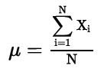

* Sample mean:

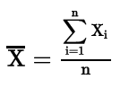

* Arithmetic means: both the population and sample means are arithmetic means as they are a sum of the observations divided by the number of observations. This value is unique in a data set and the sum of deviation of each observation from the mean is always zero (is the only measure of central tendency where this happens).

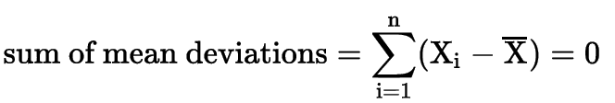

* Weighted mean:

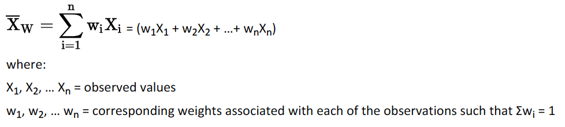

The weighted mean is used to calculate portfolio returns.

* Median: different to the arithmetic mean, the median is not affected by outliers. When there are outliers, the median is a better measure of central tendency. When the number of observations is an even number, the median will be the arithmetic mean between the two centered observations.
* Mode: a data set may have more than one mode or not mode at all. When there is one, two and three modes, the distribution is said to be unimodal, bimodal and trimodal respectively.
* Geometric mean: is used for calculating returns over multiple periods or when measuring compounded growth rates.



When calculating the geometric mean for a set of returns, the following formula is used (to avoid having negative values I think):



The geometric mean is always less than the arithmetic mean.

* 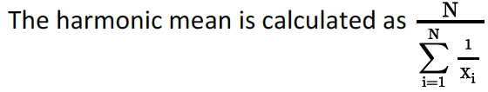Harmonic mean:

It is used, for instance, to calculate the average cost of shares purchased over time. This mean is lower than the geometric mean.

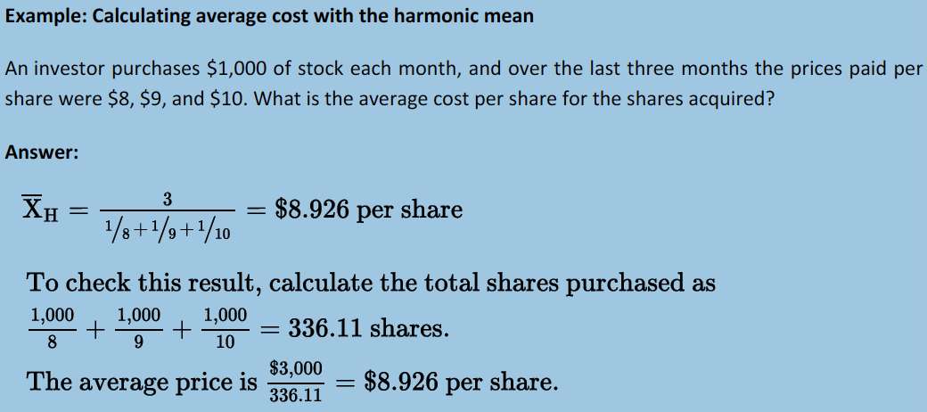

## Calculate and interpret quartiles, quintiles, deciles and percentiles.

Quantile is the general term:

* Quartiles: distribution divided in four.
* Quintile: distribution divided in five.
* Decile: distribution divided in ten.
* Percentile: distribution divided in a hundred.

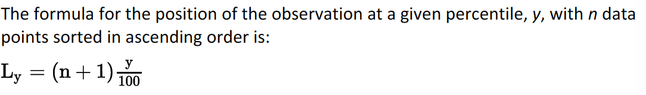

Quantiles can also be represented by portions of the observation. With measures of central tendency, quantiles are known as measures of location.

## Calculate and interpret 1) a range and a mean absolute deviation and 2) variance and standard deviation of a population and of a sample.

Dispersion -> variability around the central tendency. In finance, the central tendency is usually considered as a measure of the reward and the dispersion as a measure of risk.

* Range: distance between the largest and smallest value in the data set:



* Mean absolute deviation (MAD): average of the absolute deviations of observations from the arithmetic mean:

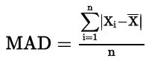

* Population variance: average squared deviations from the mean. Uses all of the members of a population:

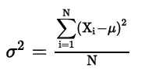

* Population standard deviation: allows to compute a squared rooted variance, which can be easily interpreted.

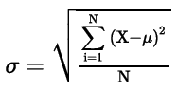

In general, σ > MAD.

* Sample variance: Applies for samples of populations.

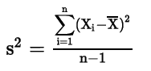

The n-1 is used in order to not underestimate the population parameter. This underestimation causes the variance to be biased.

* Sample standard deviation:

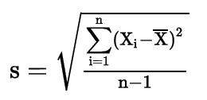

## Calculate and interpret the proportion of observation falling within a specified number of standard deviations of the mean using Chebyshev’s inequality.

Chebyshev’s inequality states that in any case, the percentage of observation that lie within k standard deviations is at least 1-1/k^2 for all k>1. This rule applies to any distribution.

## Calculate and interpret the coefficient of variation and the Sharpe ratio.

Relative dispersion is the variability in a distribution relative to a reference point. This principal helps to make dispersion measures comparable.

The coefficient of variation is a standardized standard deviation, measuring risk per unit of expected return:



Also known as the Sharpe measure or reward-to-variability ration, the Sharpe ratio measures the excess return (as it considers the market premium) per unit of risk:

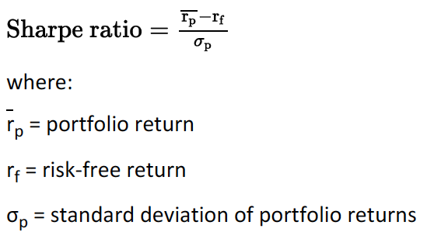

Limitations:

* When comparing two negative Sharpe ratios, is not necessary true that the higher ratio implies a higher risk adjusted return, as higher risk will make the ratio closer to zero.
* The ratio uses standard deviation which is not the best measure of dispersion for asymmetric return distributions.

## Explain skewness and the meaning of a positively or negatively skewed return distribution.

Skewness (oblicuidad) refers to the extent to which a distribution is no symmetrical.

* Positively skewed distribution: is characterized by outliers in the right tail and it is known as to be skewed to the right.
* Negatively skewed distribution: is characterized by outliers in the left tail and it is known as to be skewed to the left.

## Describe the relative locations of the mean, median and mode for a unimodal, nonsymmetrical distribution.

For symmetrical distributions, the mean, median and mode are equal.

For positively skewed:

* The mode is less than the median, which is less than the mean as the mean is affected by right tail outliers.

For negatively skewed:

* The mean is less than the median, which is less than the mode as the mean is affected by left tail outliers.

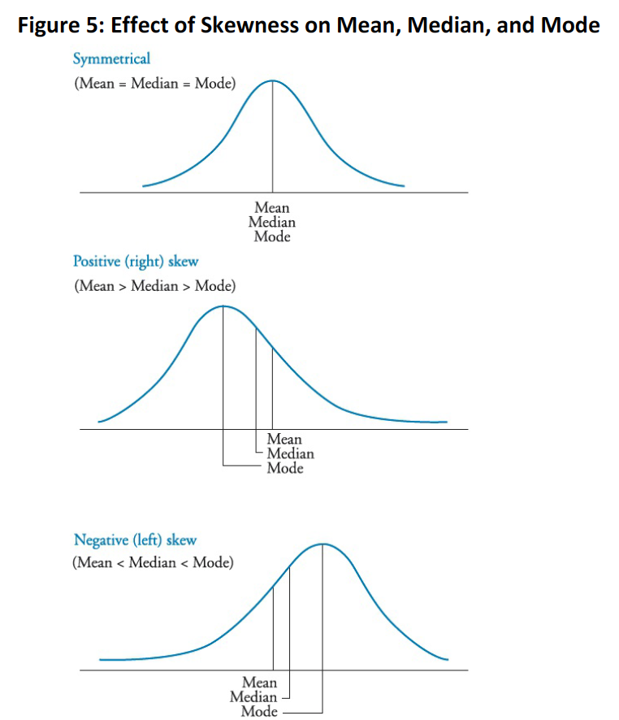

## Explain measures of sample skewness and kurtosis.

Kurtosis refers to the degree of how much is the distribution more or less peaked than a normal distribution.

* Leptokurtic: more peaked than a normal distribution, fat tails.
* Platykurtic: flatter than a normal distribution.
* Mesokurtic: has the kurtosis as a normal distribution.

Excess kurtosis: when it has more or less kurtosis than a normal distribution.

Skewness is calculated with the following formula:

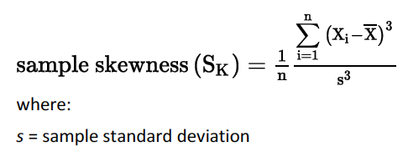

Right skewed -> positive skewness because deviations above the mean are large on average.

Left skewed -> negative skewness.

No skewed -> 0

Kurtosis is calculated eith the following formula:

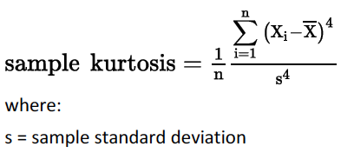

Normal distribution = 3

Leptokurtic > 3

Platykurtic < 3

Excess kurtosis -> Whenever the excess’s absolute value is above or below three, the excess will be the absolute value of:



## Compare the use of arithmetic and geometric means when analyzing investment returns.

Geometric mean is an appropriate method of past performance while the arithmetic mean tends to indicate future performance of just one year. For more than one year, the geometric mean is better. REVISAR LO DE +100 -50

# Reading 9: Probability Concepts

## Define a random, an outcome, an event, mutually exclusive events and exhaustive events

Random variable -> an uncertain number.

Outcome -> an observed value from a random variable.

Event -> an outcome or a set of outcomes.

Mutually exclusive events -> events that cannot happen at the same time.

Exhaustive events -> include all possible outcomes. This means that it refers to events from which all the possible outcomes can be forseen.

## State the two defining properties of probability and distinguish among empirical, subjective and a priori probabilities

Properties:

1. A probability of occurrence of an event is between 0 and 1.
2. When events are exclusive or exhaustive, the sum of their probabilities should equal one.

Empirical probability -> established using past data.

A priori probability -> uses reasoning and inspection processes.

Subjective probability -> involves personal judgement.

## State the probability of an event in terms of odds for and against the event

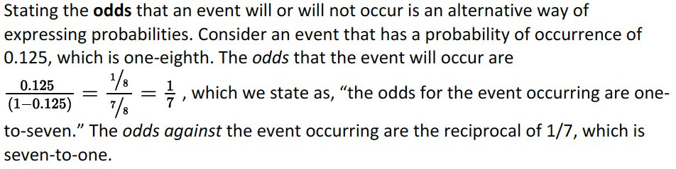

By reversing the calculation, I can get the probability.

To pass from prob to odds, simply divide the prob by 1-prob. To go from odds to prob, simply divide the odds but, before doing it, add one denomitor.

## Distinguish between unconditional and conditional probabilities

Unconditional probability: known as marginal probability, referes to the probability of an event without taking into account past or other events.

Conditional probability: the probability of occurrence is affected by other events. When the word given is used, it refers to a condition. This type of probability is represented as P(A **l** B) (the probability that A occurs given B occurs) and it is also known as likelihood. COMO SE CALCULA

## Explain multiplication, addition and total probability rules

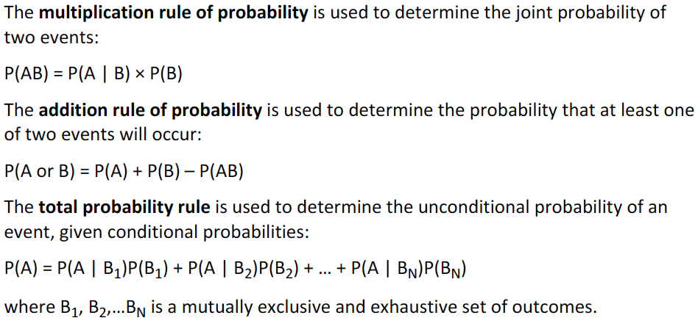

## Calculate and interpret the joint probability of two events, the probability of at least one of two events will occur, given the probability of each and the joint probability of the two events and a joint probability of any number of independent events

Joint probability: its is the probability that two events will occur. It is calculated by multiplying the probability that A occurs given B does and by adding the unconditional probability of B.

P(AB) = P(A | B) × P(B)

At least one of two events will occur: it is calculated with the following formula:

P(A or B) = P(A) + P(B) – P(AB)

The subtraction is made to avoid double counting a part of the probability of not mutually exclusive events.

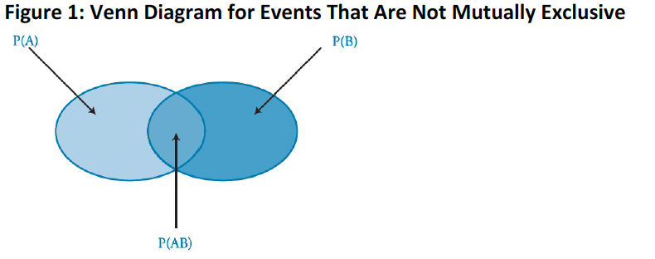

Joint probability of any number of independent events:

P(AB) = P(A) × P(B)

*As a general tip, the word “and” refers to multiplication and the word “or” to addition.

## Distinguish between dependent and independent events

Independent events are the ones in which their condition of occurrence is not influenced by other events:

P(A | B) = P(A), or equivalently, P(B | A) = P(B)

Dependent events is then, the opposite.

## Calculate and interpret an unconditional probability using the total probability rule

IC is read “the complement of I,” which means “not I.”

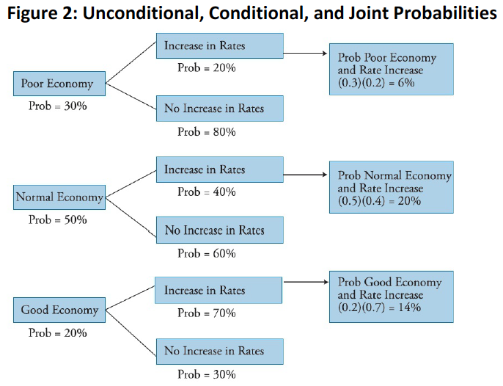

First column: Unconditional

Second column: conditional

Third column: joint.

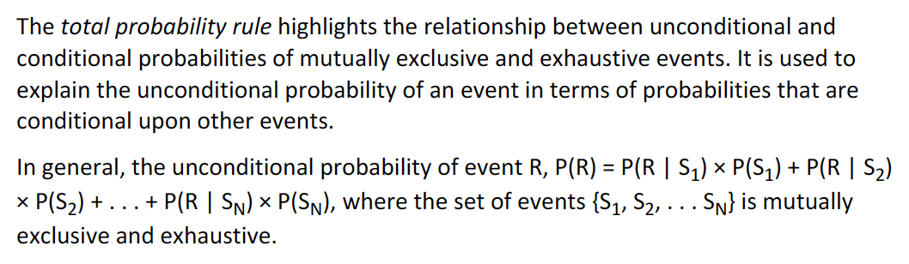

**Expected value**

Average value of various events of a random variable. Is the “best guess”.



## Explain the use of conditional expectation in investment applications

Using the total probability rule, we can estimate the (unconditional) expected return on the stock as the sum of the expected return given no tariff times the probability a tariff will not be enacted plus the expected return given a tariff times the probability a tariff will be enacted.

## Explain the use of a tree diagram to represent an investment problem

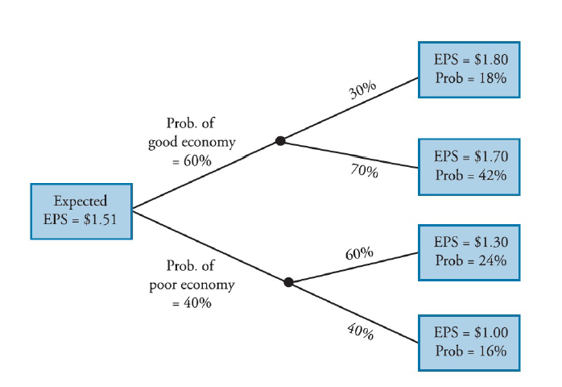

## Calculate and interpret covariance and correlation

They help to check how one variable behaves in relation to another.

Covariance:



It then shows the relationship of two variables in terms of their movement from their own mean. Calculating a covariance of an assets with itself will result in its variance.

Its range goes from negative to positive infinity.

The covariance can be also computed considering different probabilities for the occurrence of events:



Correlation is a standardized covariance and it is calculated as follows:

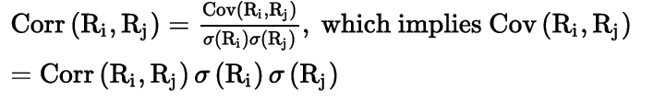

The correlation then shows the linear relationship between variables.

## Calculate and interpret the expected value, variance and standard deviation of a random variable and of returns on a portfolio

The expected value can be calculated using the following formula:

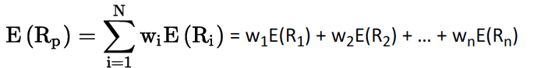

The portfolio variance is calculated like this:

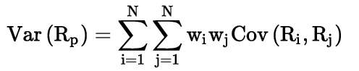

This formula can be explained with these examples:

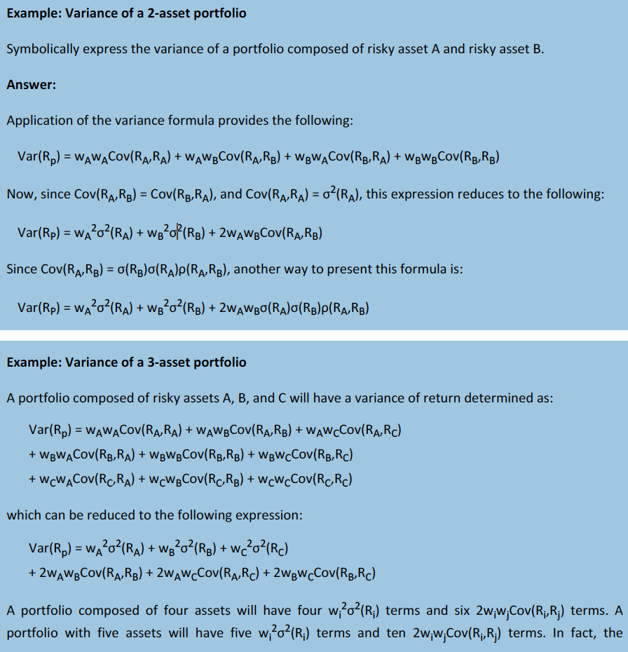

## Calculate and interpret covariance given a joint probability function

Son puros ejemplos.

## Calculate and interpret an updated probability using Bayes’ formula

This method is used when a set of new information will affect the probability of occurrence of an event.

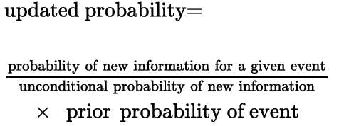

REVISAR EJEMPLOS

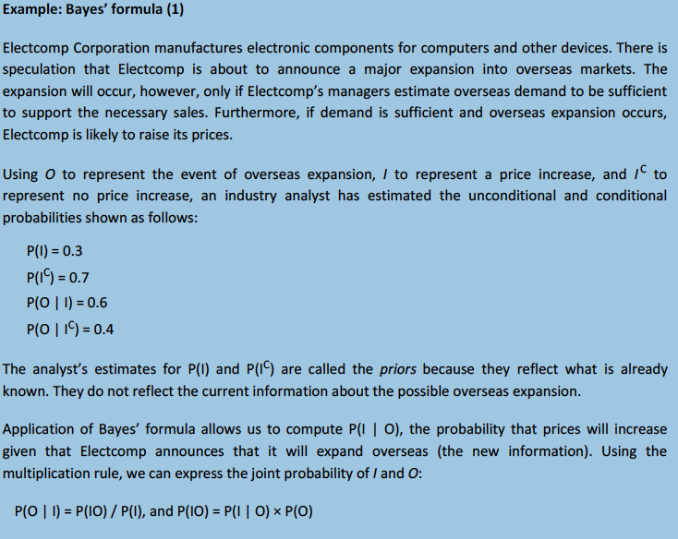

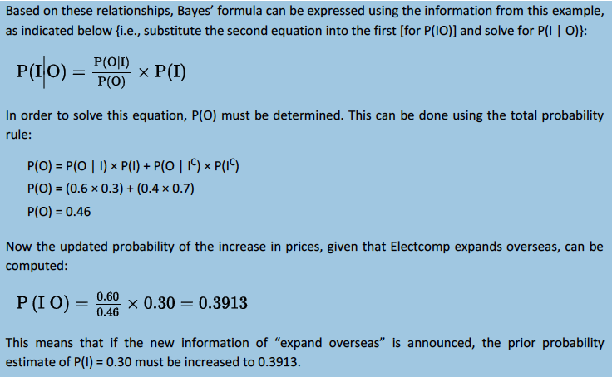

## Identify the most appropriate method to solve a particular counting problem and solve counting problems using factorial, combination and permutation concepts.

Factorial simply shows the total number of ways that a set of categories can be assigned to n objects.

Labeling happens when n items can receive one of k different labels. The total number of DIFFERENT ways in which labels can be assign is calculated as the following:



*The number of items that receives label 1 y n1. If I have 8 stocks and I want to assign 3 to one label and five to another, the formula will go as follows: 8!/(3!*5!)

The combination formula is used to find the total number of ways of selecting r items from a set of n items. It just implies two option: either be or not be chosen.



Permutation implies a specific ordering (order matters, meaning that AB is different from BA) of a group of objects. How many groups of size r in specific order can be chosen from n objects:



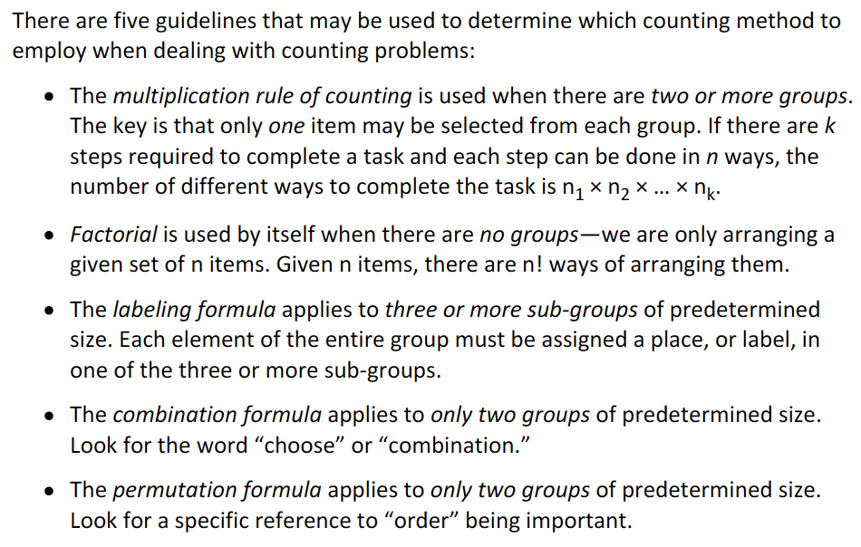

# Reading 10: Common Probability Distributions

## Define a probability distribution and distinguish between discrete and continuous random variables and their probability functions

## Describe the set of possible outcomes of a specified discrete random variable

A **probability distribution** describes the probabilities of all of the possible outcomes of a random variable.

Meanwhile, a **discrete random variab**le is one from which its possible outcomes can be counted.

A **probability function** allows to determine the probability of occurrence of a specific outcome.

**Continuous random variables** are the ones that may take infinite number of outcomes. It might be limited with positive or negative boundaries but it still has an infinite number of possible outcomes.

## Interpret a cumulative distribution function

## Calculate and interpret probabilities for a random variable given its cumulative distribution function

Also known as a simple distribution function, a cumulative distribution function defines the probability that a random variable is equal or less to a specific value. It is expressed as F(x)=P(X=<x).

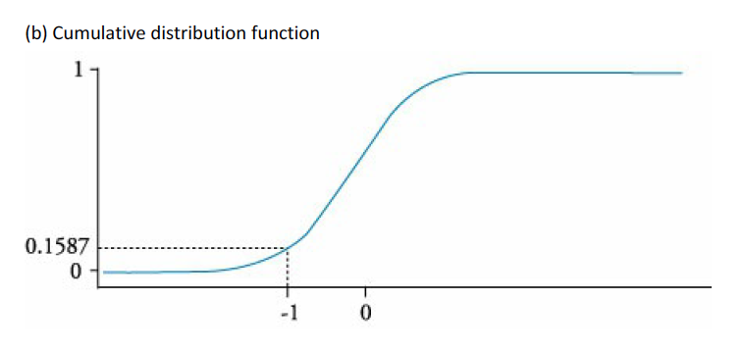

A density distribution is the normal distribution that is normally seen:

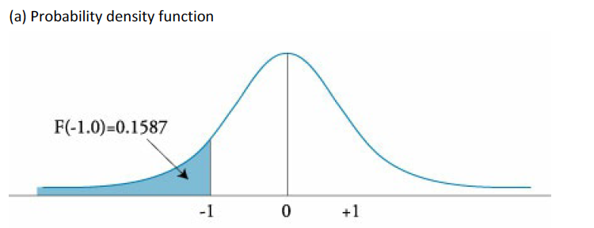

## Define a discrete uniform random variable, a Bernoulli random variable and a binomial random variable

## Calculate and interpret probabilities given the discrete uniform and the binomial distribution functions

A **discrete uniform random variable** is a special case of discrete variable where all of probabilities for the different possible outcomes is the same. The cumulative distribution will look something like this:

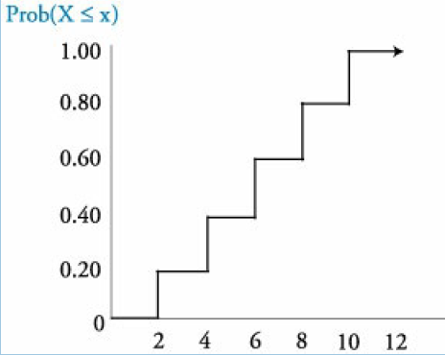

A **binomial random variable** is one that can only take two values (normally 1 or 0).

A **Bernoulli random variable** is a binomial random variable where the number of trials is only one.

The binomial probability function is described as it follows:

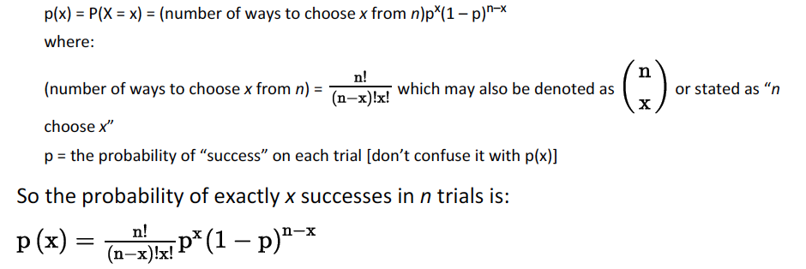

The second part of the formula is the joint probability of having x successes in n trials considering both the probability of succeeding and the probability of failing.

The expected value and the variance of a binomial random variable is calculated as:

expected value of X = E(X) = np

variance of X = np(1 – p)

## Construct a binomial tree to describe stock price movement

The terms up transition probability and down transition probability are terms used when applying a binomial model to describe either an increase or decrease on a stock price. The binomial tree is a graphic representation of this model. In this case, s is the price, u is up and d is down:

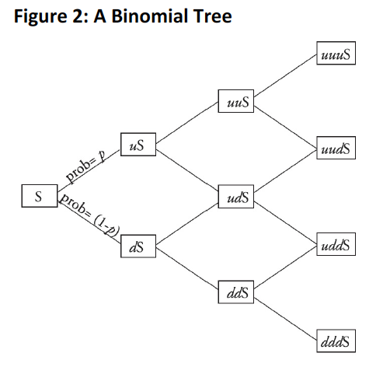

## Define the continuous uniform distribution and calculate and interpret probabilities, given a continuous uniform distribution

Continuous uniform distribution refers to a distribution where all the outcomes have the same probability and it is limited between the boundaries a and b. A graphical example of the function can be:

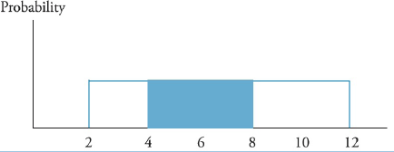

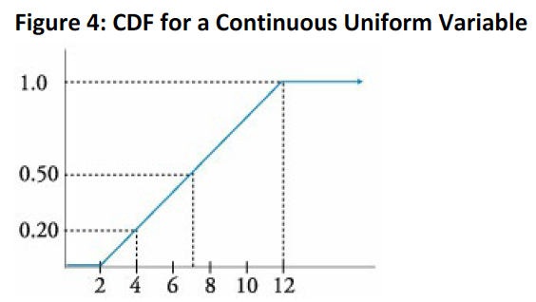

## Explain the key properties of the normal distribution

Properties:

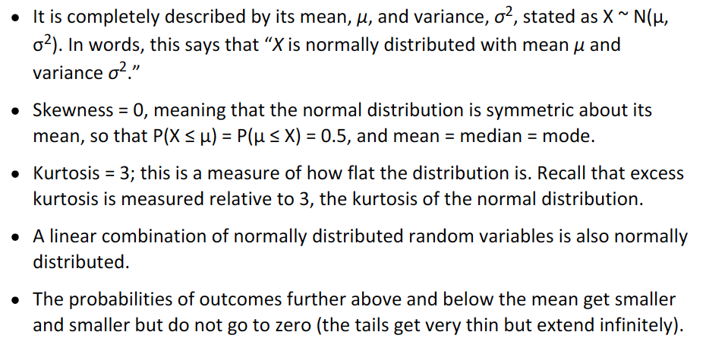

## Distinguish between a univariate and a multivariate distribution and explain the role of correlation

Multivariate distributions show the probabilities associated with a group of random variables. Its relevance is only high when the two variables are somehow related.

A multivariate normal distribution, for instance, will have n number of means, n variances and 0.5n(n-1) pair-wise correlations.

## Determine the probability that a normally distributed random variable lies inside a given interval

A confidence interval is a range in which the values of a variable are expected to be in x% of the times.

For normal distributions:

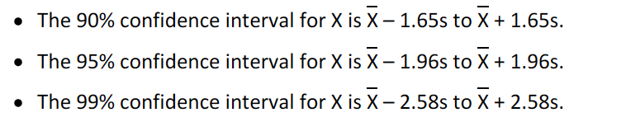

## Define the standard normal distribution, explain how to standardize a random variable and calculate and interpret probabilities using the standard normal distribution

A standardized normal distribution has an average of zero and a standard deviation of 1. To standardize a normal distribution the z-value must be calculated considering an observation that wants to be standardized:

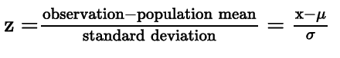

Having the observation represented as the z-value or z-score or z-statistic, the observation is the standardized (meaning that if all of the observations are transformed, the mean of the sample will be zero and the standard deviation will be one).

CUal es la diferencia entre la cumulataive dist func y la density’

It is also important to review how are the probabilities of occurrence calculated using z-values.

## Define shortfall risk, calculate the safety-first ratio and select an optimal portfolio using Roy’s safety-first criterion

Shortfall risk refers to the probability that a return or value of an assets falls below a certain value.

The minimum acceptable value is known as the threshold level. The safety criterion states the probability of reaching the threshold level should be minimized.

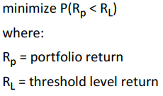

If the returns are normally distributed, the safety-first ratio can be calculated and should be maximized in order to comply with the safety criterion:

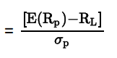

This formula is actually similar to the Sharpe ratio and the same as the z-value calculation. Therefore, it can be used to stablish the probability of falling below the threshold value.

## Explain the relationship between normal and lognormal distributions and why the lognormal distribution is used to model asset prices

The lognormal is simply calculated as ex where x is a random distributed variable. The characteristics of a lognormal distribution are that it is skewed to the right and it cannot take negative values:

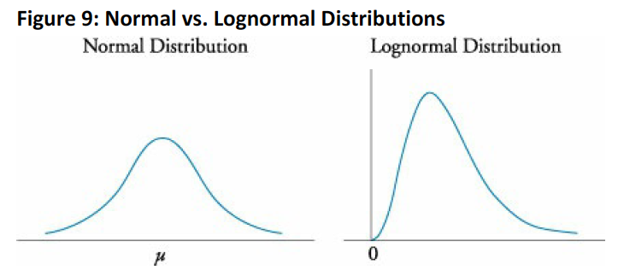

An advantage of using lognormal distribution, is that negative prices will not exist and, in the cases of returns, the variable that is modeled is price relatives, which equal to today’s price divided by yesterday’s price.

## Distinguish between discretely and continuously compounded rates of return and calculate and interpret a continuously compounded rate of return, given a specific holding period of return

The discretely compounded returns are the normal ones, as their compounding period is discrete. Continuously compounded returns are calculated when the compounding periods are really high. To calculate the effective annual rate of a continuously compounded return:



Here, the RCC can be also calculated from the effective annual rate by doing simple algebra.

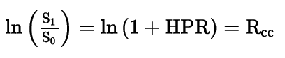

When wanting to calculate a HPR for a certain time frame considering a RCC:



So, a continuously compounded return can be added.

## Explain Monte Carlo simulation and describe its applications and limitations

The Monte Carlo simulation follows the following procedure:

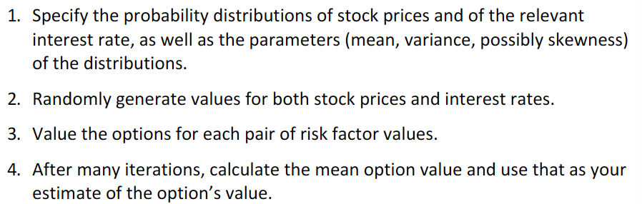

Uses and limitations:

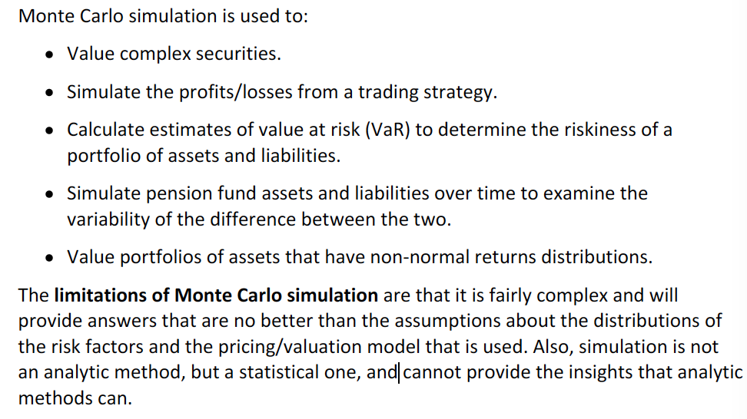

## Compare Monte Carlo simulation and historical simulation

Historical simulation generates de “random” variables based on the actual past changes on value of the variable of study. Although it uses the actual distribution, history is not always the best estimation of the future and, also, the historical simulation does not allows the analyst to perform what-if analysis.

# Reading 11: Sampling and Estimation

## Define simple random sampling and a sampling distribution

## Explain sampling error

Simple random sampling consists on extracting n completely random observation of a population. Systematic sampling consists on selecting every nth member of a population.

Sampling error is the difference between a sample statistic and its population parameter. (sample mean – population mean or sample variance – population variance…)

Sample distribution is simply a probability distribution of the statistics of different samples that come from the same population.

## Distinguish between simple random and stratified sampling

Stratified sampling uses specific characteristics to group a population. From each group, a random sample is then taken.

## Distinguish between time-series and cross-sectional data

Time-series data are observations of a specific variable over a set of time with the same time intervals between the observations.

Cross-sectional data are taken at a single point in time from different or just one variable.

Longitudinal data are observations of multiple variables of the same entity.

Panel data are observation of multiple entities of the same variable.

## Explain the central limit theorem and its importance

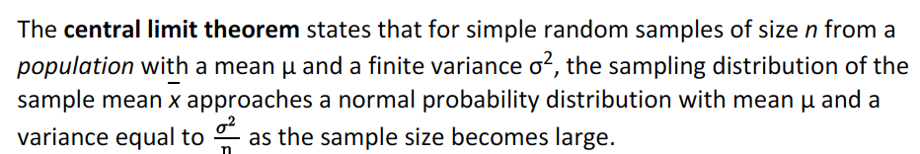

As long as the sample size is larger or equal to 30, inference from the sample can be done from the whole population regardless the population’s distribution.

In simpler words, the means of the samples are similar to a normal distribution with a mean equal to the one of the population and variance equal to the variance of the population divided by the sample’s size (standard error2).

## Calculate and interpret the standard error of the sample mean

The standard error is the standard deviation of the distribution of sample means.

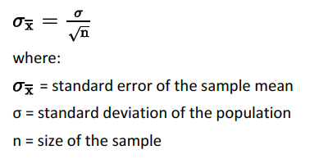

## Identify and describe desirable properties of an estimator

The desired properties are:

* Unbiasedness: happens when the expected value equals to the parameter: 
* Efficiency: happens when the variance of the sampling distribution (of means) is lower than the one of other estimators (variance of single samples).
* Consistency: happens when an increase in the sample size implies a reduction of the standard error of the estimator.

## Distinguish between a point estimate and a confidence interval estimate of a population parameter

Point estimates: single values to estimate population parameters. Estimators result in a point estimate.

Confidence interval is composed of a range of values in which the population parameter is expected to lie.

## Describe properties of Student’s t-distribution and calculate and interpret degrees of freedom

Is appropriate for small samples (n < 30) from population with normal distribution.

Degrees of freedom = n – 1

This distribution has fatter tails. However, as the degrees of freedom increase, the distribution tends to become a normal distribution, making its tails thinner and a higher center spike.

t-distribution makes it harder to reject the null hypothesis due to the fatter tails, implying wider intervals when determining a confidence interval.

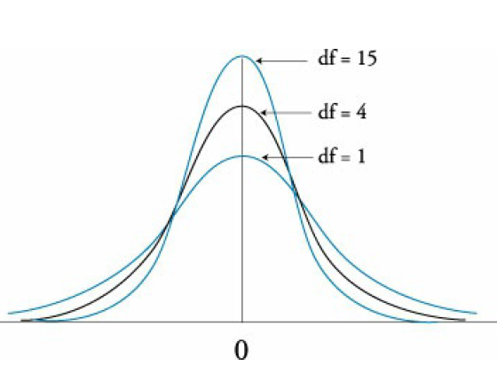

## Calculate and interpret a confidence interval for a population mean, given a normal distribution with a known population variance, an unknown population variance or an unknown variance and a large sample size

NO ME QUEDA MUY CLARO POR QUE Y CUANDO USAR POPULATION Y SAMPLE MEAN, VARIANCE…

1 – alpha is the level of significance while the alpha is the degree of confidence.

Construction of confidence intervals:

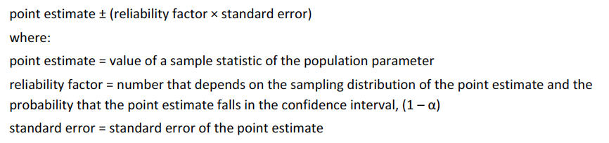

Specifically, for normal distributions, the formula for a confidence interval for the population mean will go as follows:

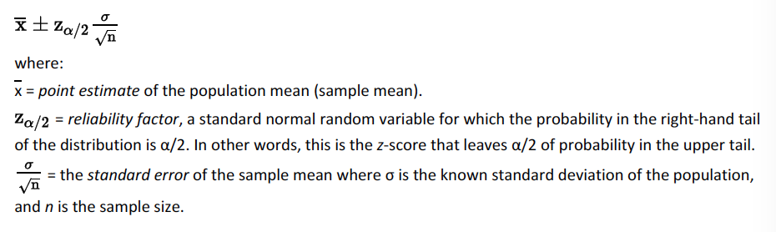

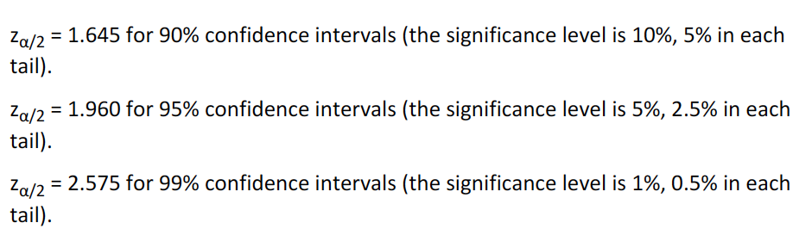

Confidence intervals for the population mean when the variance is unknown (the t-distribution is used):

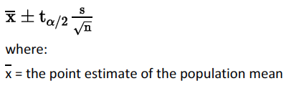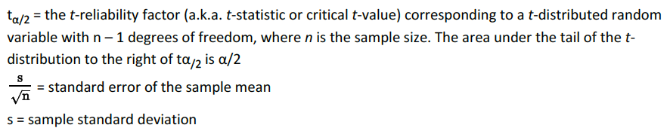

Confidence interval for the population mean when the variance is unknown given a large sample for any type of distribution:

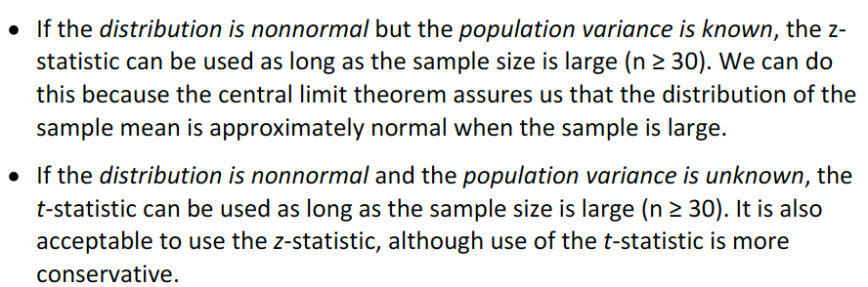

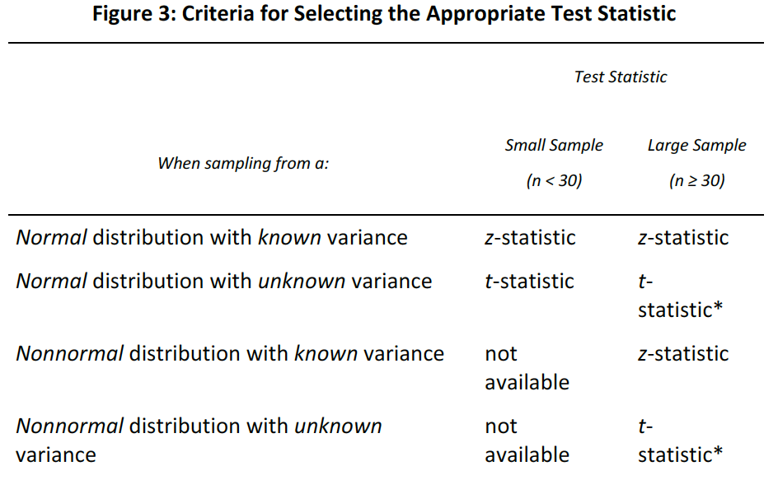

## Describe the issues regarding selection of the appropriate sample size, data-mining bias, sample selection bias, survivorship bias, look-ahead bias and time-period bias

Data-mining bias: When data-mining, someone might reach and found certain patterns that are statistically valid. However, if no economic theory supports it, it is not reliable.

Sample selection bias: When a some of the data is excluded, usually because of the lack of availability.

Survivorship bias: This is related to the availability of data due to the fact that the published data is no longer available. The thing is that usually the data that is no longer available had the worst performance (funds with a bad performance are normally discontinued).

Look-ahead bias: occurs when the study uses estimates and forecasts.

Time-period bias: if the time in which the data is collected is either too long or short, bias can be presented (data mining in the case of too short and data changes if it is too long).

# Reading 12: Hypothesis Testing

## Define a hypothesis, describe the steps of hypothesis testing, and describe and interpret the choice of the null and alternative hypotheses

Hypothesis are stated in terms of the parameter to be tested.

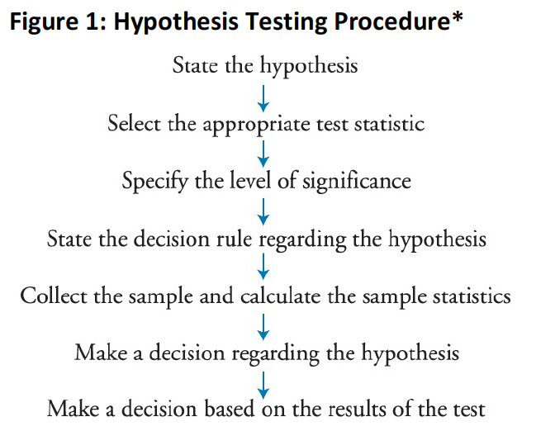

Null hypothesis: H0, the hypothesis that wants to be rejected.

Alternative hypothesis: Ha, what the researcher wants to happen.

## Distinguish between one-tailed and two-tailed tests of hypotheses

A two-tailed test appears when there are two critical values or rejection points (normally when equality is used to define the hypotheses). So, to reject the null hypothesis then:

Test statistic > upper critical value or

Test statistic < lower critical value (that is the same as the upper but negative).

The critical value will be the tvalue or zvalue calculated considering the stated alpha.

COMO ANUALIZAR MEDIDAS????

Standard error = standard deviation / sqrt(n)

When stating that two values are significantly different, the variation and size of the sample is considered.

For a one tailed hypothesis test, and upper tail alternative hypothesis will be that the mean is higher than a certain value and a lower tail will consider that is lower than a certain value.

## Explain a test statistic, type I and type II error, a significance level, and how significance levels are used in hypothesis testing

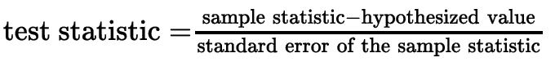

Standard error:

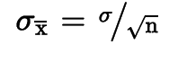

Type I error: rejection of the null hypothesis when it is actually true. The probability of making an error when rejecting it. -> this is the pvalue.

Type II error: Failure to reject the null hypothesis when it is actually false. The probability of making an error when supporting the null hypothesis because it is false.

Alpha is the probability of making a type I error.

## Explain a decision rule, the power of a test and the relation between confidence intervals and hypothesis tests

“Accept” should not be said… it must be either “support” or “reject”.

A decision rule is literally what needs to happen to reject the null hypothesis.

Power of the test refers to the probability of correctly rejecting the null hypothesis when it is false (1 – P(type II error)). Probability of making the right call by rejecting.

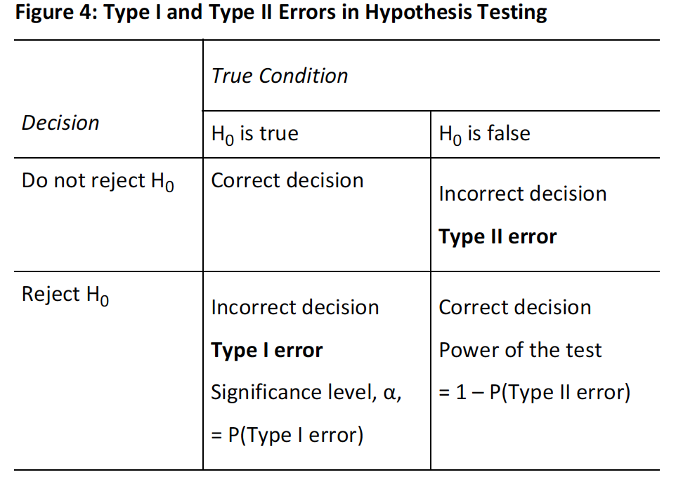

Decreasing type I error probability (by decreasing the level of significance or alpha) increases the probability of type II and the power of the test. El primer párrafo de la 350 está complicado de entender

Level of significance -> Alpha

Level of confidence -> 95%

**Relationship between confidence intervals and hypothesis testing**

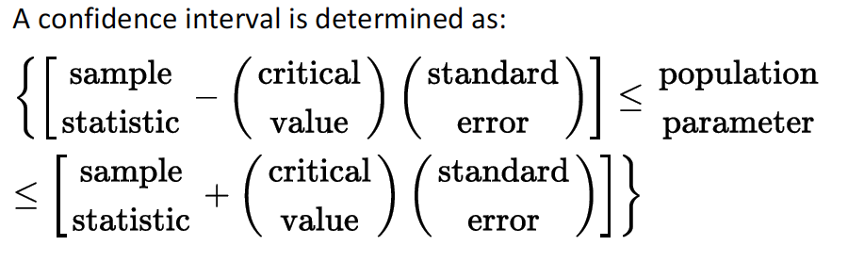

The factor that relates hypothesis testing with a confidence interval is the critical value.

## Distinguish between a statistical result and an economically meaningful result.

These are two different concepts. The first one is barely statistical while the second one tries to explain that in finance and economics there are other variable that should be accounted before assuming significance such as any extra costs or even risk.

So the economic significance looks at the tests from a broader sight and considers extra variables to comply with the economic objective.

## Explain and interpret the p-value as it relates to hypothesis testing

The p value is the probability of making an error when rejecting a null hypothesis. Then, is the lowest level of significance for which a null hypothesis can be rejected.

When considering a p value of five, for one tail it would be just five at one side. Meanwhile, when considering a two tailed test, it would be 2.5 at each side.

I can calculate the probability of getting a value higher or lower than a value using the test statistic.

## Identify the appropriate test statistic and interpret the results for a hypothesis test concerning the population mean of both large and small samples when the population is normally or approximately normally distributed and the variance is 1) known or 2) unknown

t-distribution or z-distribution choice depends on the samples’ sizes, the distribution and if the variance of the population is known.

**t- test**

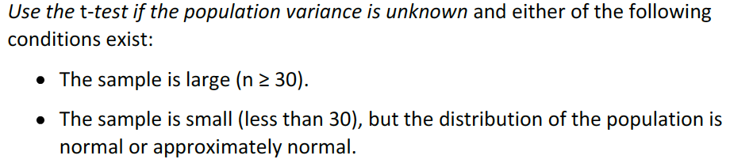

The statistic t with n-1 degrees of freedom is computed as:

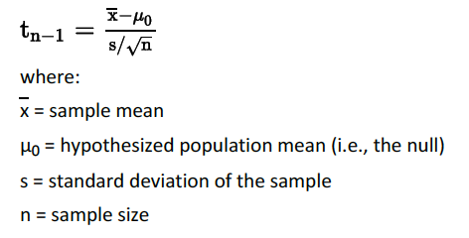

**z-test**

Is appropriate when the population is normally distributed and has a known variance.

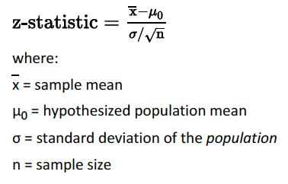

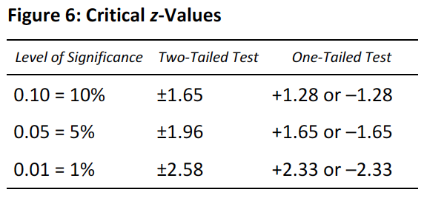

In the case that the sample size is large, and the population variance is unknown:

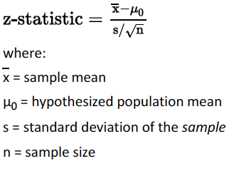

However, it is important to consider that for unknown population variance cases, the t-test is more conservative.

## Identify the appropriate test statistic and interpret the results for a hypothesis test concerning the equality of the population means of two at least approximately normally distributed populations, based on independent random samples with 1) equal or 2) unequal assumed variances

When making a test regarding two population means, populations must be normally distributed and the samples taken should be independent. Here t test are used. Also, it is important to consider that there are two cases to consider when testing difference in population means (population variance can be unknown):

1. Population variances are assumed to be equal and sample observations are pooled.
2. Population variances are not equal.

What is a pooled variance??

For the first case, the statistic can be computed as:

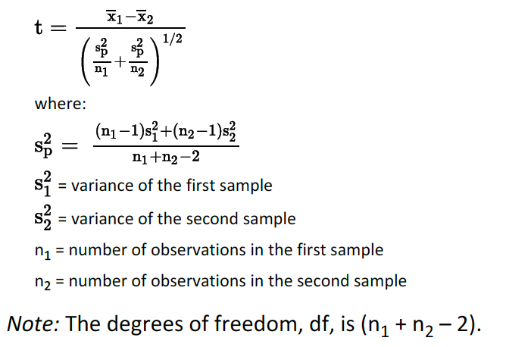

As the variances are assumed to be equal, variances of the means are simply added.

For the second case:

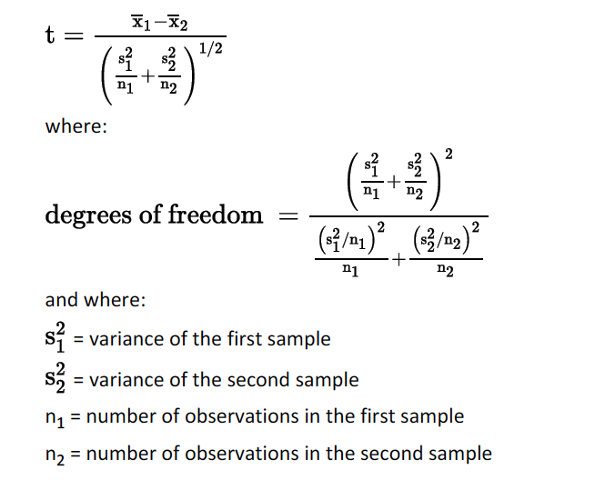

Here, what it is important to memorize is that there are two cases and that, whenever the means are closer, the t statistic will be smaller.

## Identify the appropriate test statistic and interpret the results for a hypothesis test concerning the mean difference of two normally distributed populations

There are cases when the samples are dependent and normally distributed. Here, paired comparisons tests are used. For this test, the objective is to determine if there is a significant difference between the average difference between the observations of the two samples and zero.

The t statistic is calculated as follows, where meow dz is commonly zero (it is the hypothesized mean of the difference, H0):

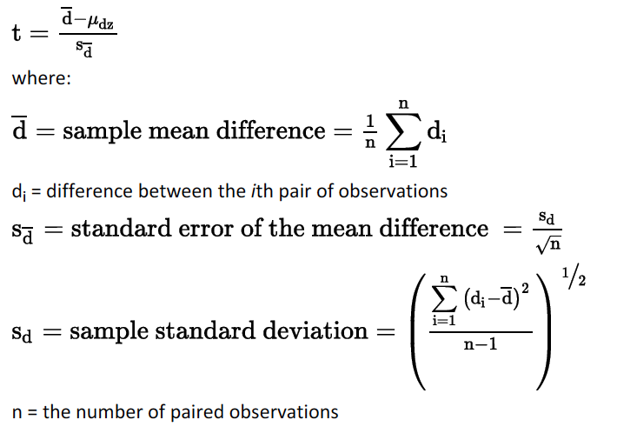

To identify between the two tests:

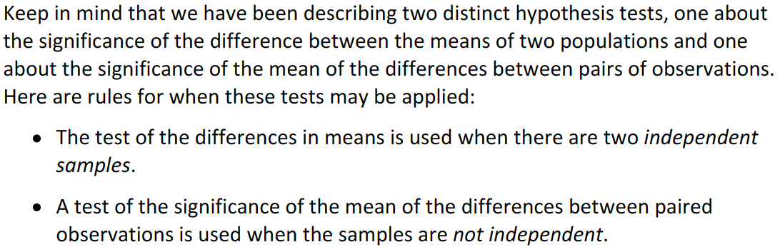

## Identify the appropriate test statistic and interpret the results for a hypothesis test concerning 1) the variance of a normally distributed population, and 2) the equality of the variances of two normally distributed populations based on two independent random samples

The chi-square test helps for tests concerning variance of a normally distributed population. A chi-square distribution is also used which is asymmetrical. This means that the critical values at the two sides of the distribution are not equal.

The table is presented from one side to another:

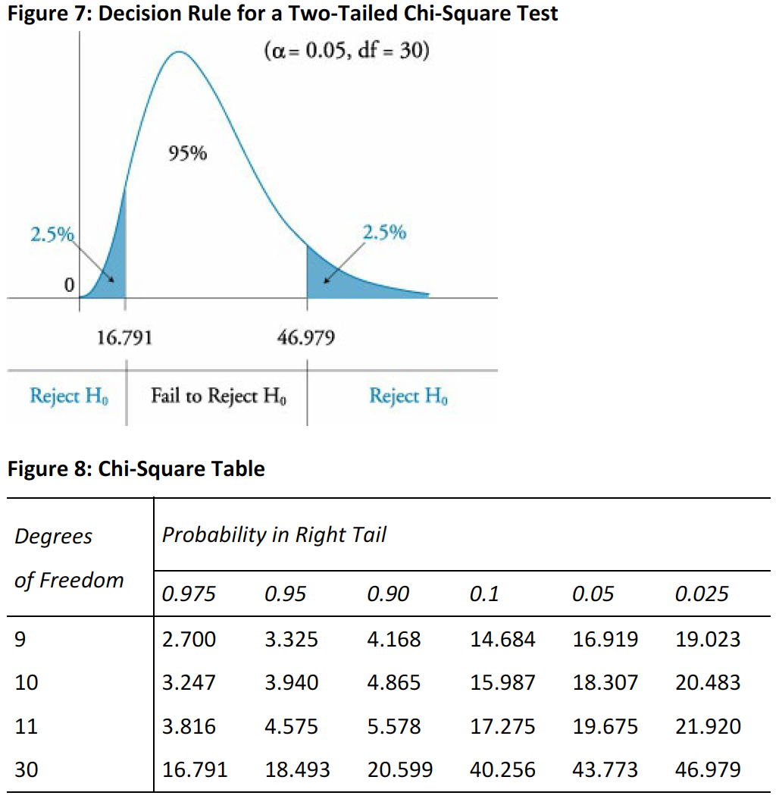

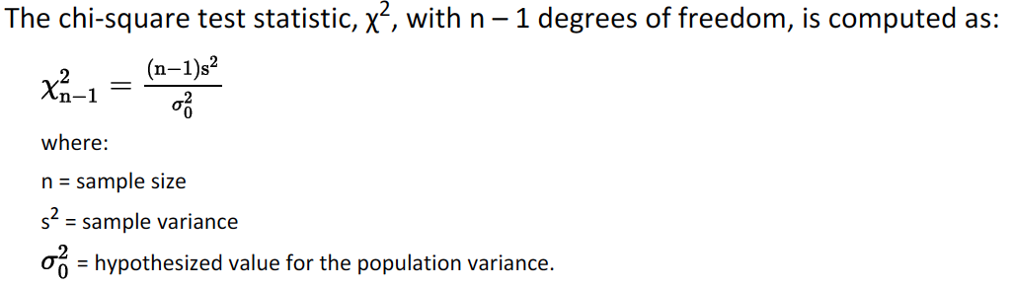

When considering two independent random samples:

Here, and F-distributed test statistic is used (F-test), where the population is assumed to be normally distributed and the samples are independent.

The F statistic is computed as:

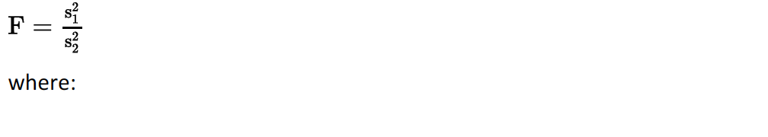

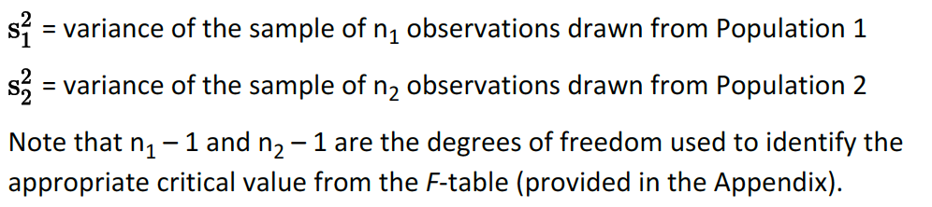

It is important to put the larger variance in the numerator, meaning that the only critical value to be considered will be the one for the right hand tail.

An F-distribution is right skewed and bounded by zero at the left side. For this distribution, the upper critical value is the reciprocal of the lower one.

Review how to extract the critical values

## Distinguish between parametric and nonparametric tests and describe situations in which the use of nonparametric tests may be appropriate

Parametric: Rely on distribution of the population and parameters assumptions (like the z-test).

Nonparametric: When the parameters are not a concern but, instead, quantities. They are used when:

1. The assumptions of distribution for the parametric test is not met (small sized non-normally distributed sample, for instance).
2. When data are ranks rather than values.
3. The test does not involve parameters such as testing whether a variable is normally distributed. The runs test (used to determine whether or not the changes of a series are random).

Spearman rank correlation test: helps to determine, using ranks, the correlation of one occurrence in one point of time with the next occurrence. A high result (like 0.85) means that a high rank this year may lead to a high rank next year. Negative will be inverse.

# Reading 13: Technical Analysis

## Explain principles of technical analysis, its applications and its underlying assumptions

Price reflect the collective behavior of buyers and sellers.

Assumptions:

* Market prices reflect rational and irrational behavior of investors.
* Efficient markets hypothesis does not hold.

It is important to point out that it is not an objective analysis. It is only useful in markets where price and volume reflect the true conditions of the whole market and can be used on assets where their intrinsic value cannot be calculated.

## Describe the construction of different types of technical analysis charts and interpret them

The time interval chosen in graphs reflects the trading horizon.

**Line charts:** show closing prices.

**Bar charts:** include open, high, low and close.

**Candlestick charts:** clear box if close>open.

**Point and figure charts:** help identify changes in direction. The horizontal axis shows changes in direction. X are increases O decreases. After three of the same character (known as the reversal size), it is assumed that a change of direction has happened and is when a new column begins.

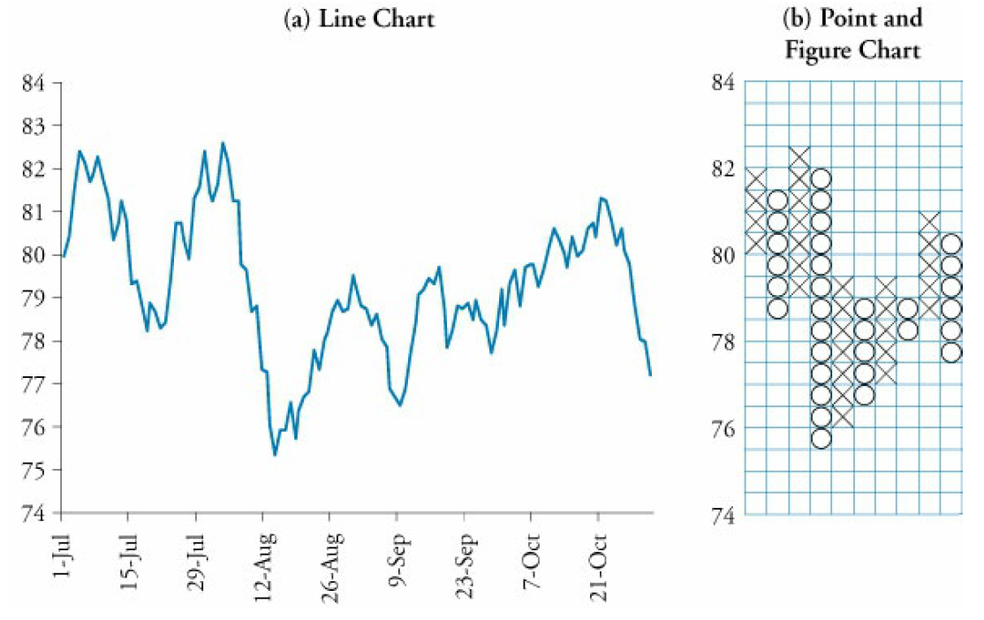

**Volume charts.**

**Relative strength analysis** implies calculating a ratio between the asset and a benchmark and graphs it. Outperformance is marked as an increasing trend.

## Explain uses of trend, support, resistances lines and change in polarity

Trends refer to a constant behavior of prices. For uptrends, trendlines connect the lows and for downtrends, the trendline connects lows. Breaking a line implies the end of a trend (breakdown when an uptrend finishes and breakout when a downtrend does.’).

Support level: buying prevents further decrease of prices.

Resistance level: selling prevents an increase in prices (top).

Change in polarity: Is a belief that states that breached support (resistance) levels become resistance (support) levels.

## Describe common chart patterns

Reversal patterns: change of trend.

Head-and-shoulders (inverse): the difference between the head and the neckline shows how much is the price expected to decrease from the neckline downwards.

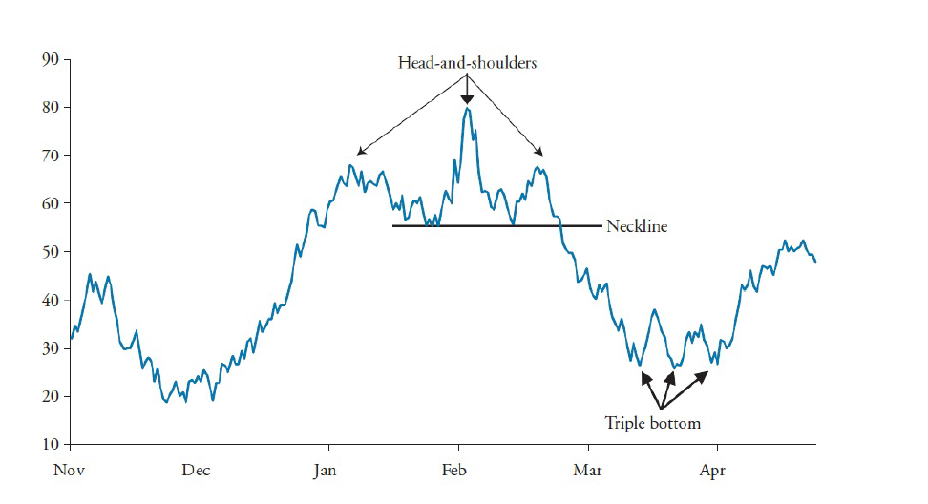

Double top and triple top (inverse) : Prices do not pass a resistance level and then, a change of trend occurs. The size of the pikes can be used to project a price target for the downtrend.

Continuation patterns: pause of a trend so it can then continue.

Triangles: Prices reach lower highs and higher lows over time and the trendlines of high and lows converge. Triangle can be symmetrical, ascending or descending. The distance between the two trendlines when the triangle begins can be used to the determine a target price in the case that the trend continues.

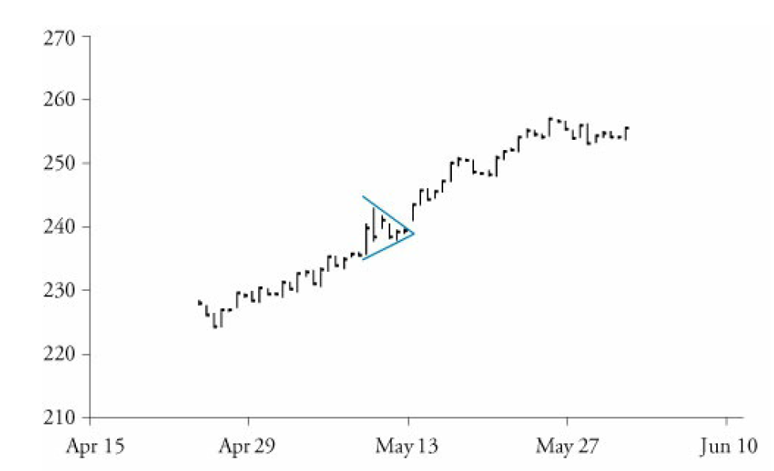

Rectangle:

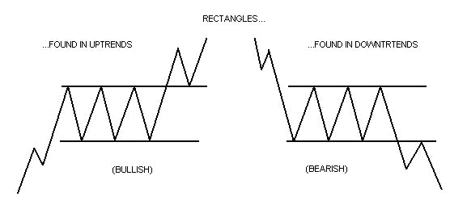

Pennant (short-term charts):

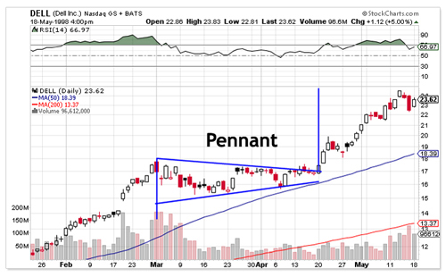

Flag (short-term charts):

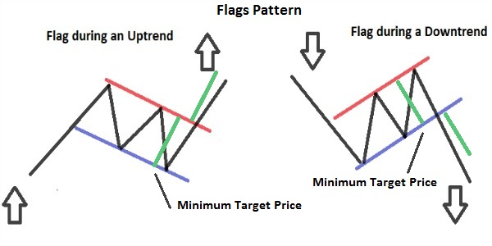

## Describe common technical analysis indicators (price-based, momentum, oscillators, sentiment and flow of funds)

Price-Based indicators:

Moving average lines: smoothens fluctuations. In an uptrend, the price is higher than the MA. Lines are often seen as support and resistance levels. Combining a short with a long MA can be useful- when the short crosses the long, a change in trend usually happens. Golden cross is the cross that appears when an uptrend begins and dead cross when a downtrend begins.

Bollinger bands: Typically uses two standard deviations. Overbought market appears when the price is at the upper band and oversold when the price gets close to the lower band.

*Contrarian strategy: buy when most traders are selling and sell when most are buying.

Oscillators: Are scaled to oscillate over given values and show if markets are overbought or oversold. They also help identify convergence (price and oscillator show the same pattern and divergence. Convergence suggest continuity of a pattern while divergence suggests a change.

Rate of change oscillator (ROC) or momentum oscillator: is the difference of the closing price of today minus the closing price of n periods before times 100 (sometimes is used as the ratio between these prices). The decisions that can be followed is to buy when the oscillator changes from negative to positive during uptrends and sell when it goes from positive to negative in downtrends.

Relative Strength Index (RSI): Ratio between total price increases to total price decreases over certain periods. Over 70 indicates overbought market and below 30 oversold.

Moving average convergence/divergence (MACD): Uses a MACD line (difference between two exponential moving averages) and a signal line which is an exponential moving average of the MACD line. Crosses of lines indicate buy/sell signals (the one that crosses is the MACD line). Use to identify convergence and divergence.

Stochastic oscillator: the %K line is the difference between the latest price and the recent low as a % of the difference between the recent high and low. The %D line is a 3-period average of the %K line. Crosses, again, indicate buy/sell signals.

**Convergence happens when the oscillator show the same pattern as the price trend and divergence is when this does not happen.**

Non-price-based indicators: Help identify sentiment (what buyers and sellers feel) and capital flows.

Put/call ratio: Is calculated as put volume/ call volume. When it increases, a negative outlook of the asset price is indicated. It is considered as a contrarian indicator. When the ratio is really high or low, it might show and overbought or sold market.

Volatility Index (VIX): Measures the volatility of options on the S&P 500 Index. High VIX suggest investor fear declines. It is often used as a contrarian indicator.

Margin debt: Increases suggest aggressive buying, and normally shows the market trend.

Short interest ratio: Increases mean a strong negative sentiment (short interest is the volume of shares borrowed and sold short). Is calculated as short interest divided by average daily trading volume. Although high levels show that prices are likely to decrease, at the long run, they show they will increase as investors will need to rebuy their stocks.

Indicators of flow of funds:

Arms or short-term trading index (TRIN):

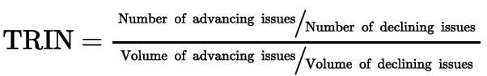

When it is close to one, it suggests funds are flowing evenly to advancing and declining stocks. Greater than one means that the majority of volume is in declining stocks. Upward spikes coincide with large daily losses.

Margin debt: Increases indicate that investors want to buy more. Decrease = want to sell.

Mutual fund cash position: mutual funds cash/total assets. It increases when the market is falling and decreases when it is rising. However, this ratio is seen as a contrarian indicator as cash accumulation may suggests that funds are preparing to buy.

New equity issuance and secondary offerings): Issuance of new shares tend to coincide with market peaks (as issuers sell at highs).

## Explain how technical analysts use cycles

## Describe the key tenets of Elliott Wave Theory and the importance of Fibonacci numbers

Cycle theory tend to identify cycle in prices. Some cycles are 4-year presidential cycles, decennial patterns, 18 year cycles, and 54 year cycle (Kondratieff wave).

Elliott wave theory suggests that in an uptrend, upward moves consists of five waves and downward moves of three waves (for a downtrend is the opposite). Each of the waves are composed of smaller waves that follow the same pattern.

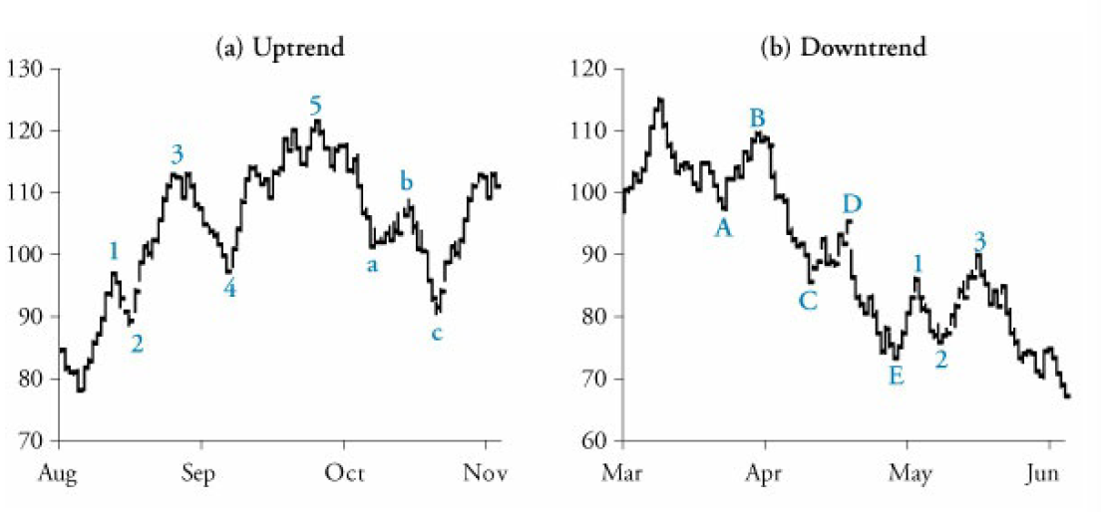

Fibonacci numbers and ratios between them (consecutively) help to stablish the relation between upward and downward moves. For instance, a down leg can be 2/3 of an up leg. Fibonacci ratios converge to 0.618 and 1.618.

## Describe intermarket analysis as it relates to technical analysis and asset allocation

Intermarket analysis studies the relationship between markets of major asset classes. Relative strength indicators help identify which assets is outperforming another one. This helps to compare the performance of markets and to choose where to invest.